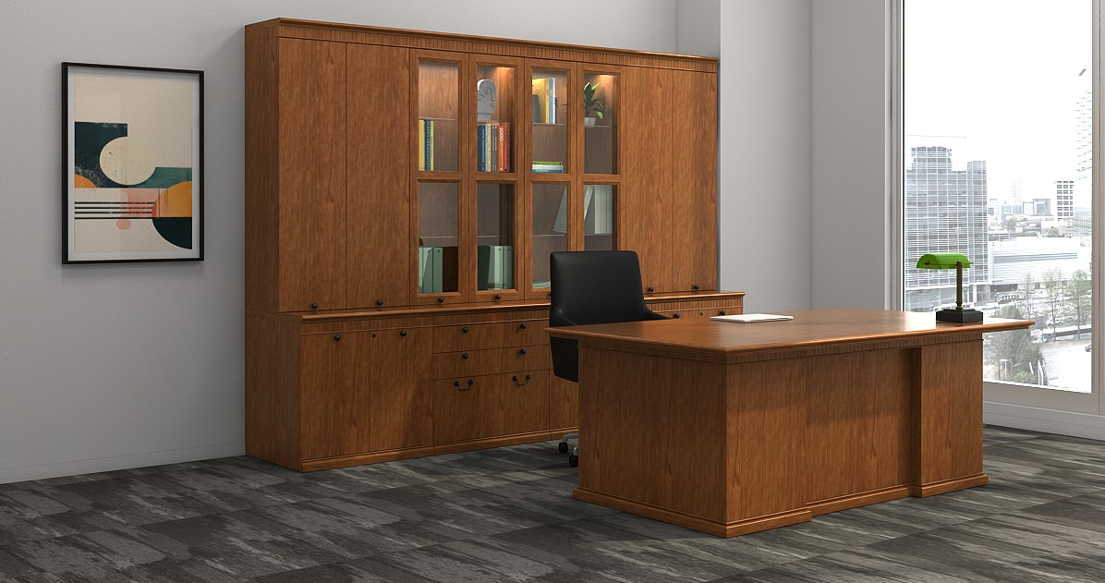**Law Office - Anthenium Casegoods** – LO.ANT01

Specifications

Wood Finish – C49 Medium Cherry

Hardware Finish – Satin Black

Seating - Vita High Back, VTH1

Upholstery - Lena Leather 9000 Black

Base – Polished Aluminum MPA